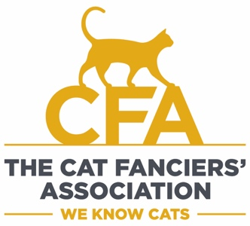
CFA Show Sponsorship Request - 2023-2024

Email request for sponsorship to Lisa Brault, lbrault@cfa.org
at least 30 days before the show (14 days for Hong Kong & China shows)

SECTION 1 – General Info – Complete All Fields

Club: Show Dates: Region:
Primary Contact Person: E-mail: Phone:
- Are you hosting this show with another club? If yes, Club name
  - Sponsorship to be equally split between both clubs? Check one - Yes / No
- Send award sponsorship to (name): (address):
  - If payment by Paypal, provide Paypal account info:
- Name and location of the show hall:
- One or two day show:
SECTION 2 – Sponsorship Info & Type Requested
Can qualify for more than one type if applicable - See Section 3.
Regular ($1,000) In-Conjunction ($1,000) Agility ($300)
Region 9 Judge Airfare Supplement - - Judge Name(s)
Infrequent-Region Judge Supplement (Reg 1-8, ID) - - Judge Name
- Approval(s) subject to CFA club receiving approved show license.
- One sponsorship per weekend in the same location for each type of sponsorship.
- Clubs may obtain additional sponsorship from other sources.
- Must follow requirements as outlined for each type of sponsorship.
- Once sponsorship request is approved, sponsorship funds will be sent after: 1) show has been held, and 2) scoring package and entry surcharge payment has been received by Central Office.
- All sponsorships granted on a first applied, first granted basis.

SECTION 3 – Types of Sponsorship
Regular - $1,000 per show
Maximum two (2) for the same club per show season.

In-Conjunction - $1,000 per show
Show held in conjunction with another registry’s show. In-Conjunction show must receive CFA Board of Directors approval.

Agility - $300 per show
Show with an official Agility ring, licensed for scoring and competition.

Region 9 Airfare - $500 per judge/per show, max $1,000
Contracted judges outside of Region 9, airfare receipt required. Maximum two (2) per club, per show season.

Infrequent Judge (all areas except Region 9) - $500 per judge/per show, max $500 - 2 shows per region/ID
Contracted judges who have not officiated in the show's region in the prior 3 show seasons.

- Rev. 4/2023

